SOP: Projects & Targets (Projects and Tasks)
Module | Projects & Targets (Projects and Tasks)
Who uses it | Project Manager, Assistant Manager, Admin, Super Admin
Version | 1.0
Issued | 21 Oct 2026
Screenshots are taken from the HRMS test copy. Names, dates and numbers are examples only.

1. Purpose
Projects and tasks decide who works on what, the hourly target per task, how much of each file QA checks, how QA hours are counted, and which SOP links agents and QA can open.

2. Screen guide - Projects & Targets
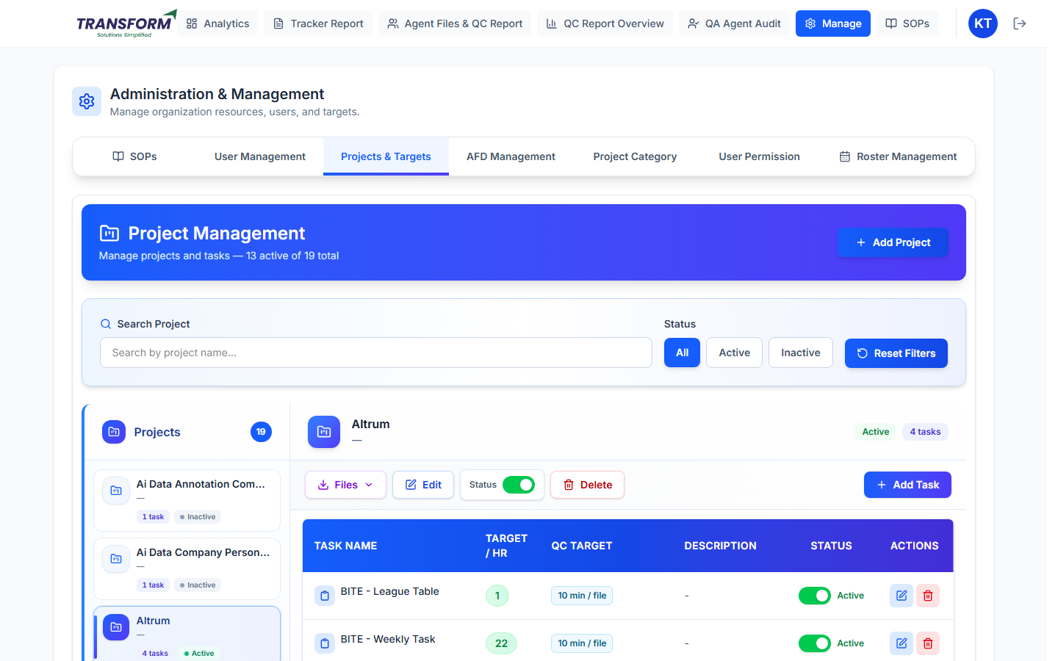
Figure 1: Project Management
Part | What it does
Add Project | Create a new project.
Search Project / Status | Find a project by name; show All, Active or Inactive.
Projects list (left) | Each project with its number of tasks and Active / Inactive. Click to open it.
Files | Project files and SOP links (download / open).
Edit | Change project details, people and SOP links.
Status switch | Make the project Active or Inactive. Inactive projects disappear from agents' lists.
Delete | Removes a project that was never used. Projects with tracker history are deactivated instead.
Add Task | Create a task in this project.
Task table | Task Name, Target / Hr, QC Target (QA hour criteria, e.g. '10 min / file'), Description, Status switch and Actions (edit, delete).

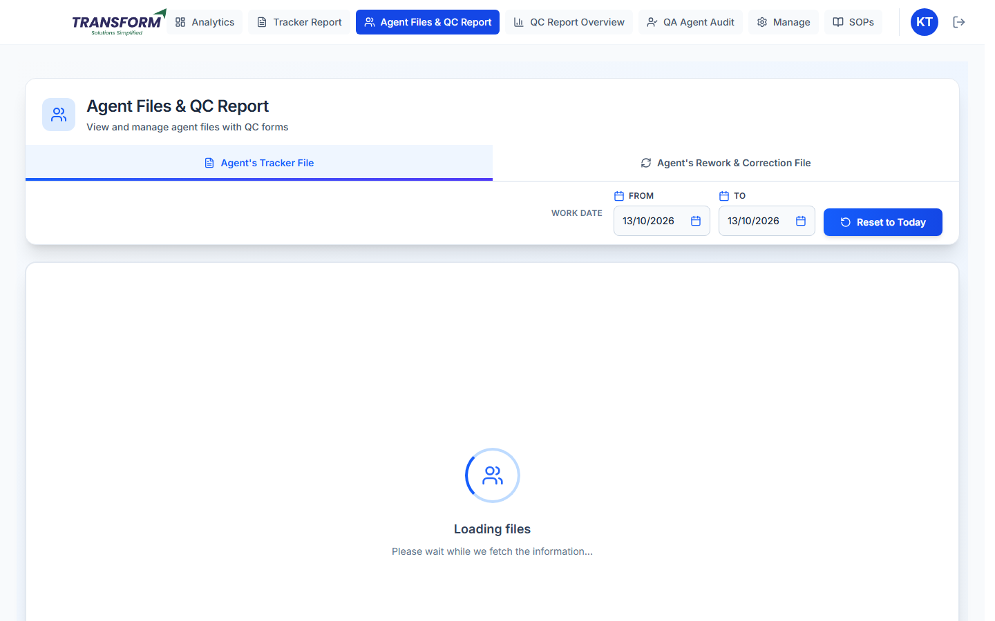
Figure 2: Files - project files and SOP links

3. Procedure - Create or edit a project
1. Click Add Project (or Edit on a project).
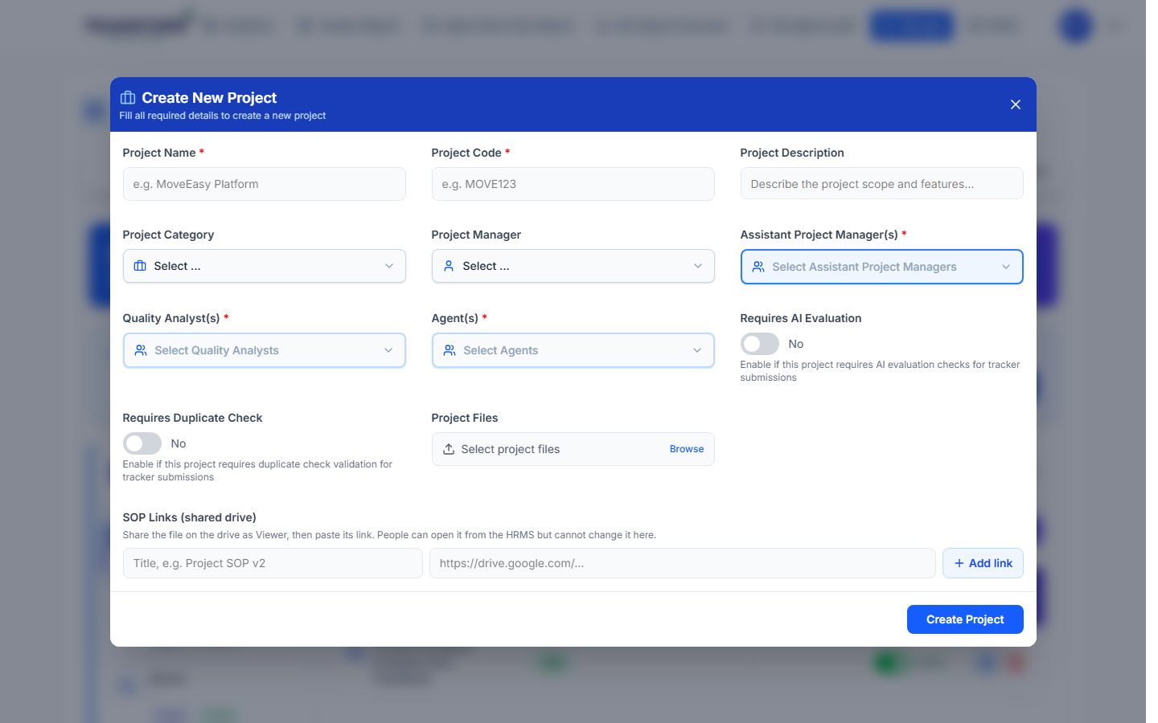
Figure 3: Create New Project
2. Fill Project Name and Project Code (required) and an optional Description.
3. Project Category decides the QC error list (AFD) QA uses. Pick the right one.
4. Choose the Project Manager, Assistant Project Manager(s) (required), Quality Analyst(s) (required; QA or Assistant Team Leader) and Agent(s) (required). Only these agents see the project in their tracker; only these QAs get its files.
5. Requires AI Evaluation: agents must run AI Evaluation on the file before submitting. Requires Duplicate Check: rows already submitted are rejected.
6. Project Files: attach reference files (on Add Project).
7. SOP Links (shared drive): type a title, paste the link and click Add link. Share the file on the drive as Viewer first. Agents see it under Project Name on Add Tracker; QA sees it on the QC form.
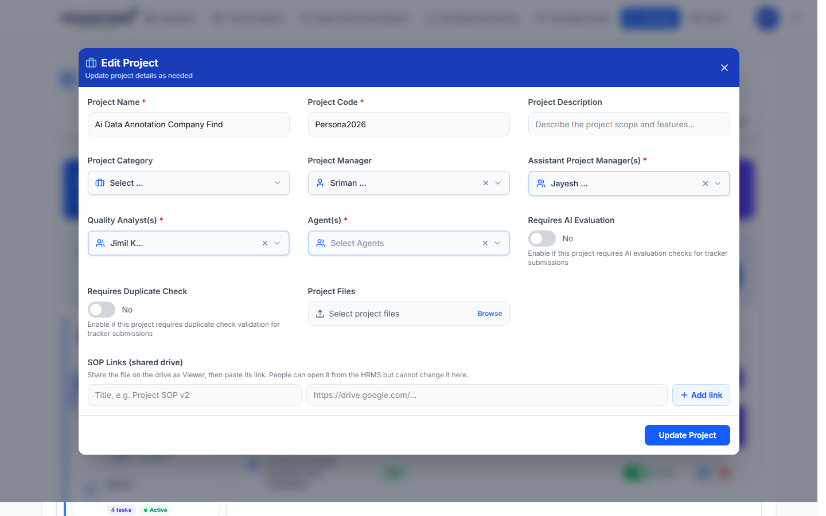
Figure 4: Edit Project - SOP Links
8. Click Create Project / Update Project.

4. Procedure - Add or edit a task
1. Open the project and click Add Task (or the edit icon on a task).
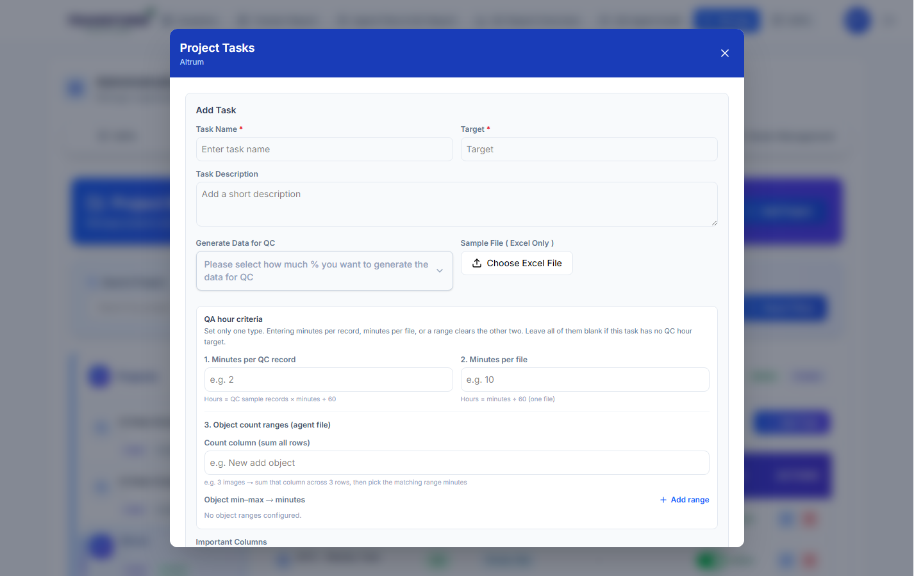
Figure 5: Add Task
2. Task Name and Target (units per hour at tenure 1.0) are required. Add an optional Task Description.
3. Generate Data for QC: the percentage of each file QA checks (for example 10%).
4. Sample File (Excel only): upload an example file. Its column names fill Important Columns.
5. QA hour criteria: set only ONE type - 1. Minutes per QC record, 2. Minutes per file, or 3. Object count ranges (a count column summed over the file, then minutes per min-max range). Entering one type clears the others; the type in use shows 'IN USE'. Leave all blank if QA hours should not be counted for this task.
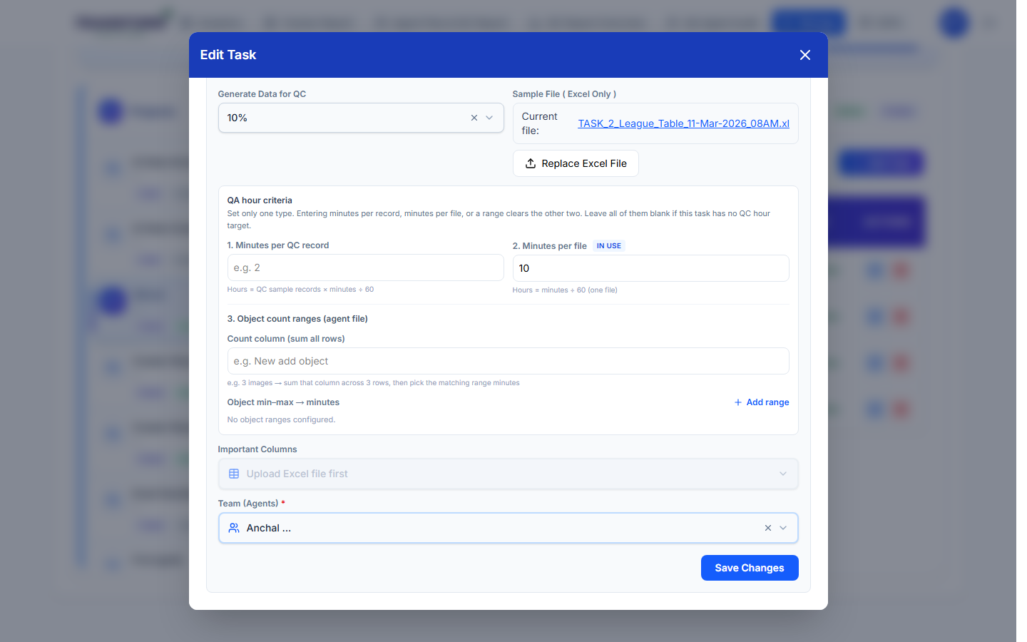
Figure 6: Edit Task - QA hour criteria in use, Important Columns, Team
6. Important Columns: the columns QA sees on the QC form (pick from the sample file's columns).
7. Team (Agents) (required): the agents who can log this task.
8. Click Submit (Add) or Save Changes (Edit).
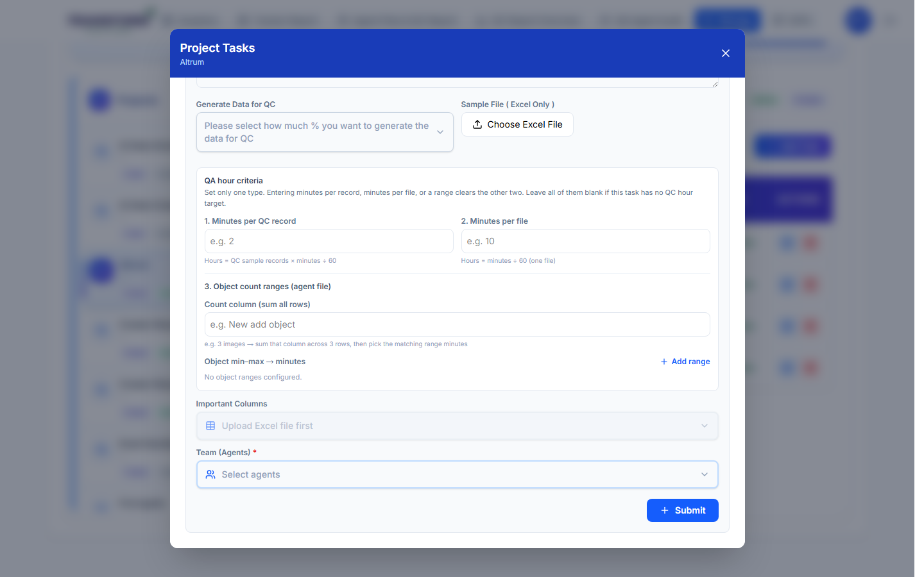
Figure 7: Add Task - bottom of the form

5. Rules to remember
- An agent's target = task Target x the agent's tenure (from User Management).
- QC % decides how many rows QA checks: rows x QC %, rounded up.
- Only one QA hour criteria type can be active for a task.
- Deactivate a task or project instead of deleting it once it has been used.

6. Common problems
Problem | What to do
Agent cannot see the project or task | Check they are in Agent(s) and the task's Team, and both are Active.
QA sees no files | Check the QA is in Quality Analyst(s).
QA sees no errors to choose | Set the Project Category; it must be linked to an AFD.
Important Columns says 'Upload Excel file first' | Upload the Sample File.
SOP link opens 'Request access' | Share the drive file with the team as Viewer.

